Welcome to University of Mandyflexx Computer Science Department. The information on this website is intended to assist both present and prospective students in their academic endeavors. This Readme will help you set up and give you important details about the project, whether you're a developer wishing to explore the codebase or a user interested in the functionalities.

1. Cloning and setup.
2. Student information.
3. Screenshots of various pages of website.
4. Project insights.

Follow these steps to clone and setup on your local machine:

1. Clone the repository:

Git clone https://github.com/moimeme28/11325735_DCIT205

Navigate to the project directory:

Cd moimeme28/11325735_DCIT205

1. Install dependencies:

npm install

1. Start the development server:

npm start.

1. Open your browser:

Visit [http://localhost:3000](http://localhost:3000/) to view the project.

Name: Osei Emma Adobea.

Student ID: 11325735.

SCREENSHOTS

Home or the index page

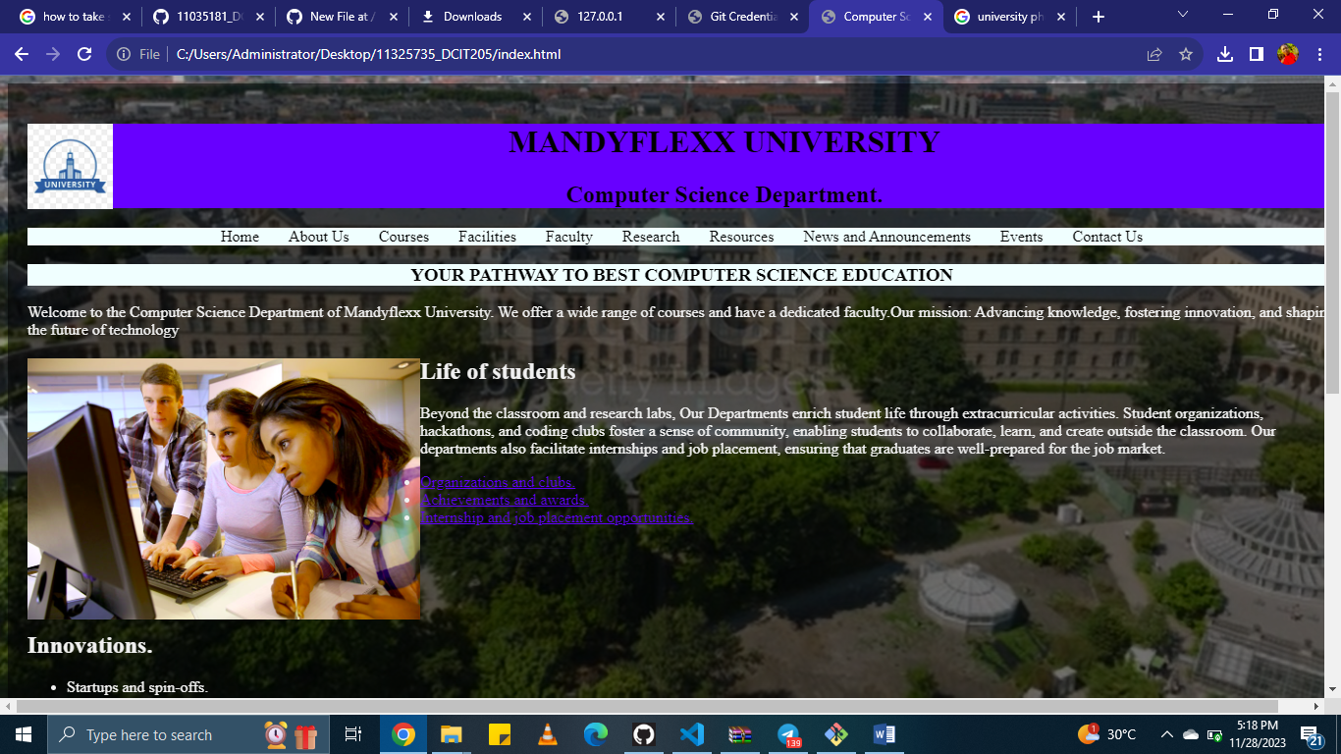

About page

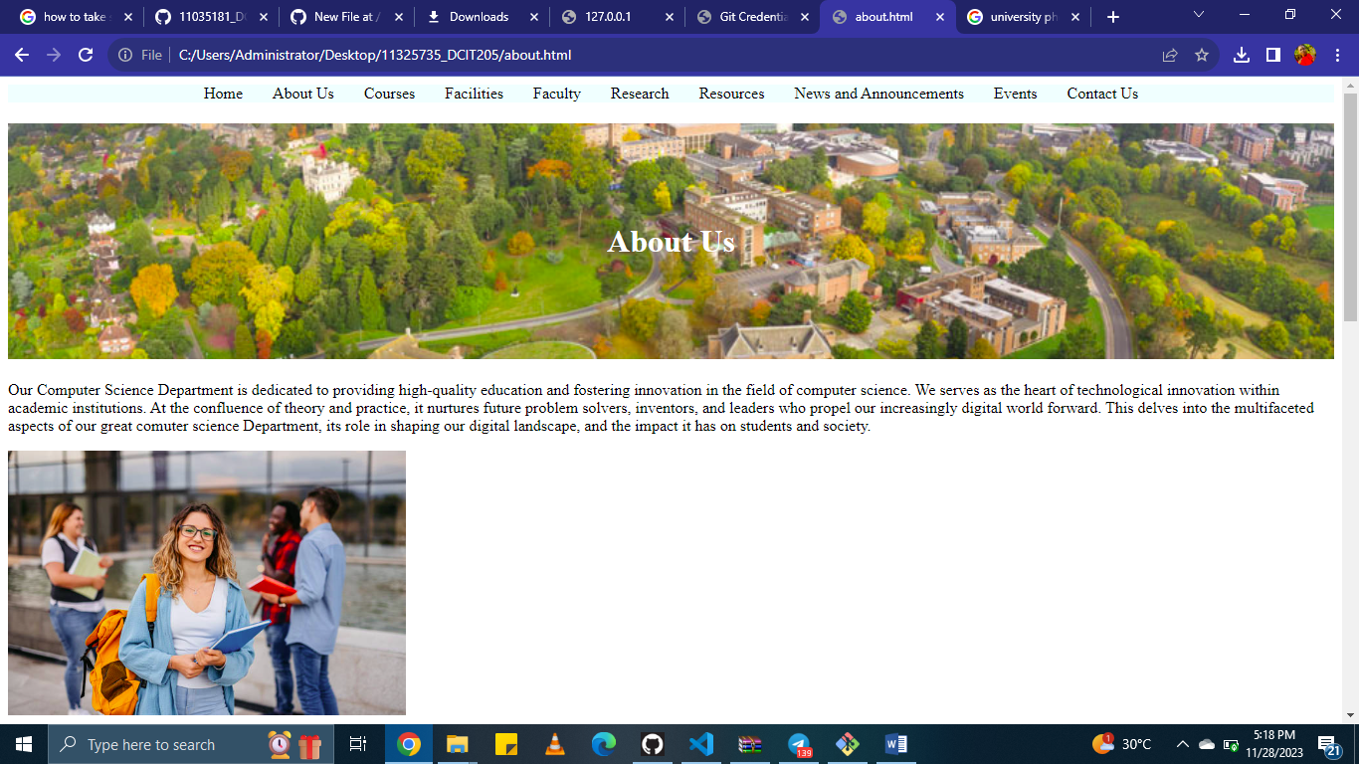

Courses page

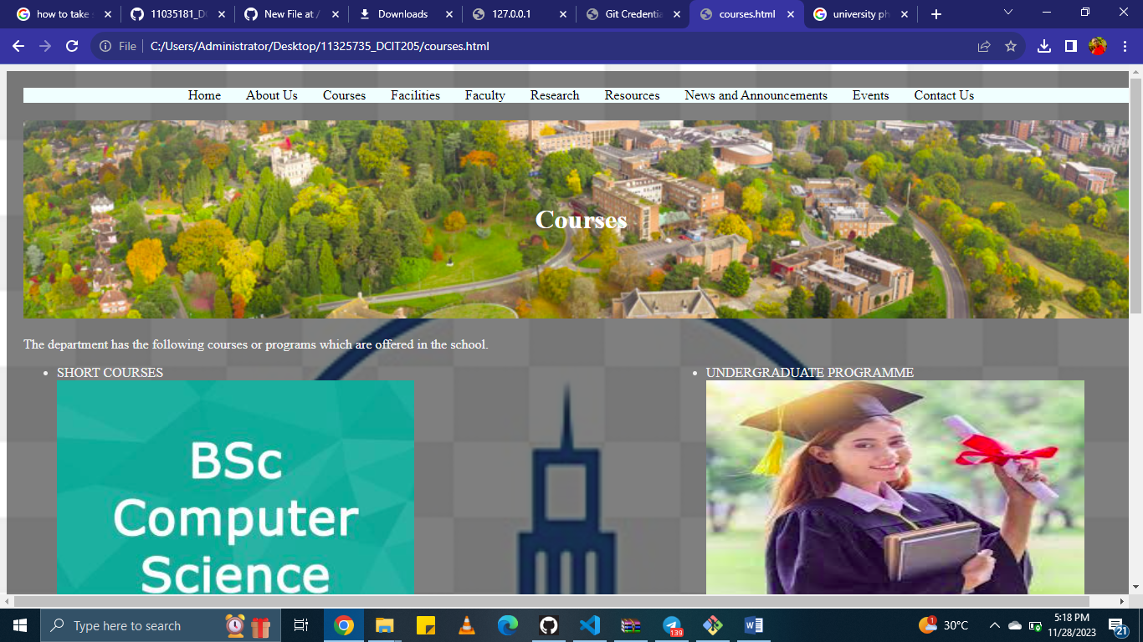

Facilities page

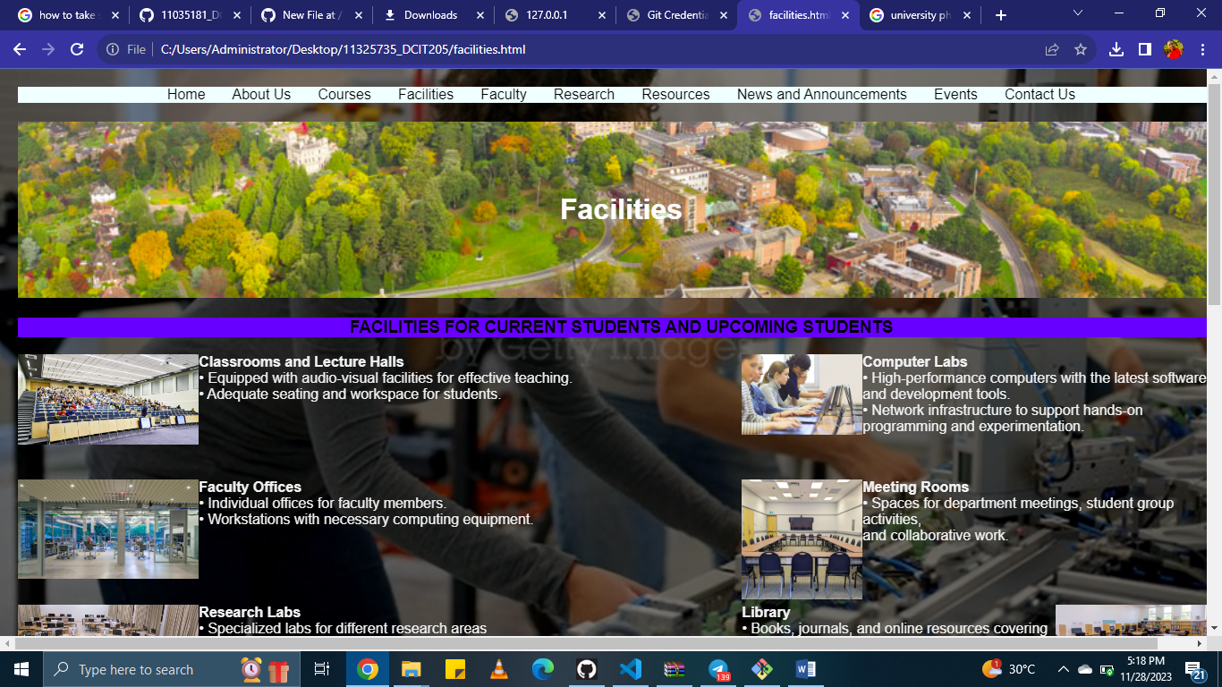

Faculty page

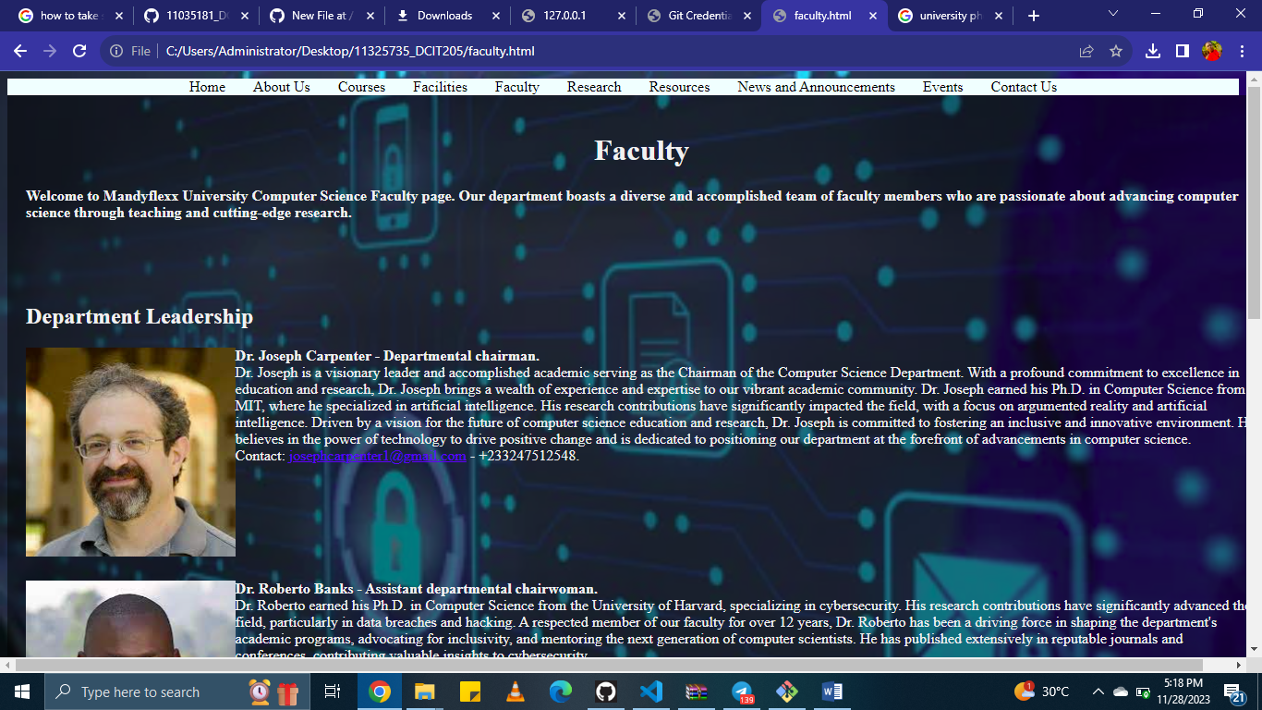

Research page

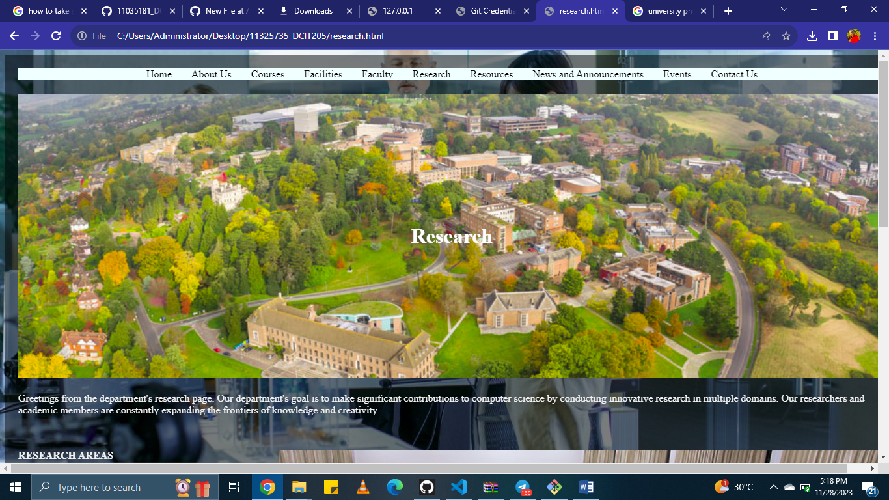

Resource page

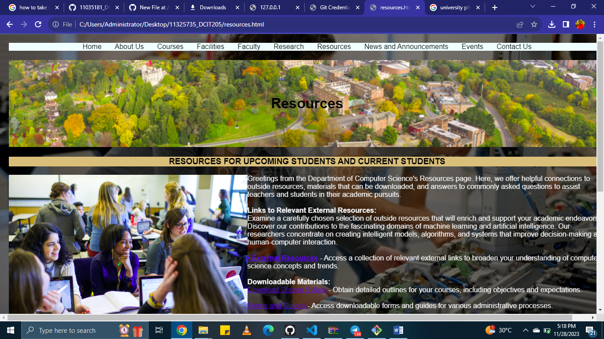

News page



Events page

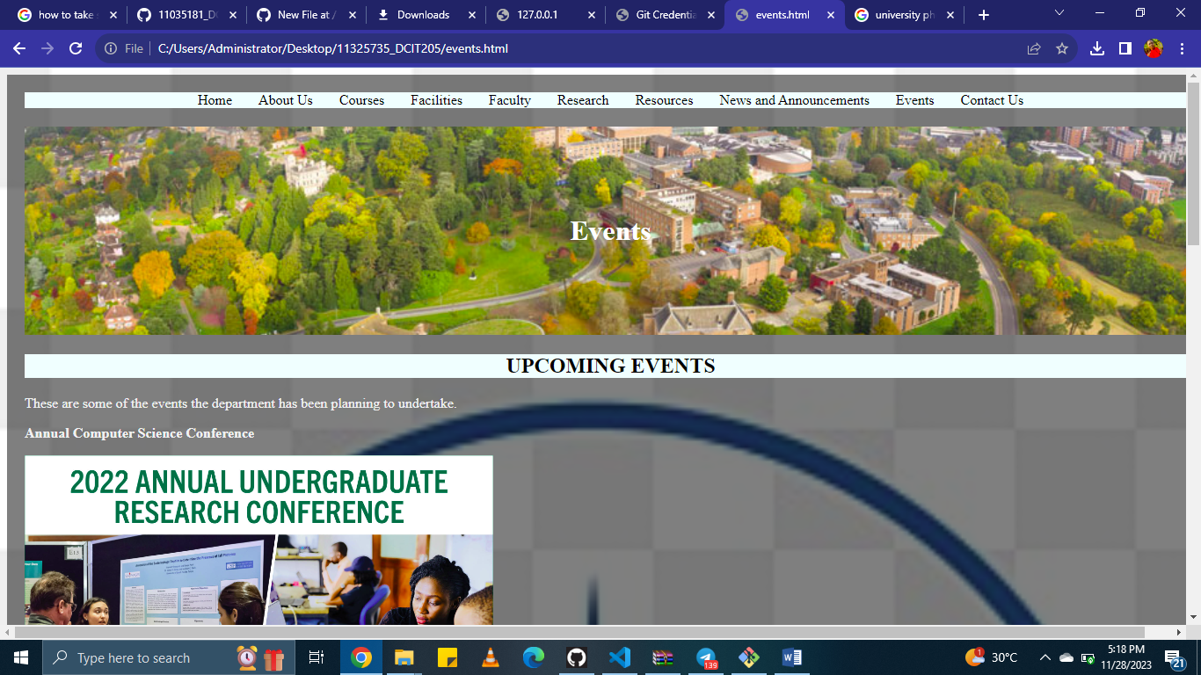

Contact page

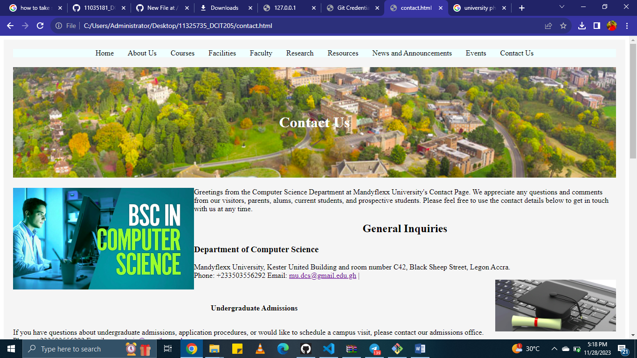

As this project has evolved, I have discovered some really insightful things and have learned the following:

1. Technical abilities in version control, HTML, CSS, GitHub.

2. Issue resolution, including optimization and debugging.

3. Project management, which includes organizing, planning, and setting priorities for tasks.